SOFTWARE ENGINEERING LAB
Household Carbon Footprint Tracker

Name | Purvik V
Section | AIML-D
SRN | PES1UG24AM211
Project | Household Carbon Footprint Tracker
Submission | Sprint Evidence and Individual Lab Reflection

1. Active Sprint and Story Point Assignment
Project: Household Carbon Footprint Tracker
Current active sprint: HCFT Sprint 3
The current sprint contains three work items. The story points assigned to the work items are shown below.
Issue | Story | Status | Story Points
HCFT-10 | View Historical Emissions | In Progress | 3
HCFT-15 | Fast Historical Charts | To Do | 5
HCFT-16 | Clear Validation and Error Messages | In Progress | 3
Total story points in Sprint 3: 11

Jira evidence – Active Sprint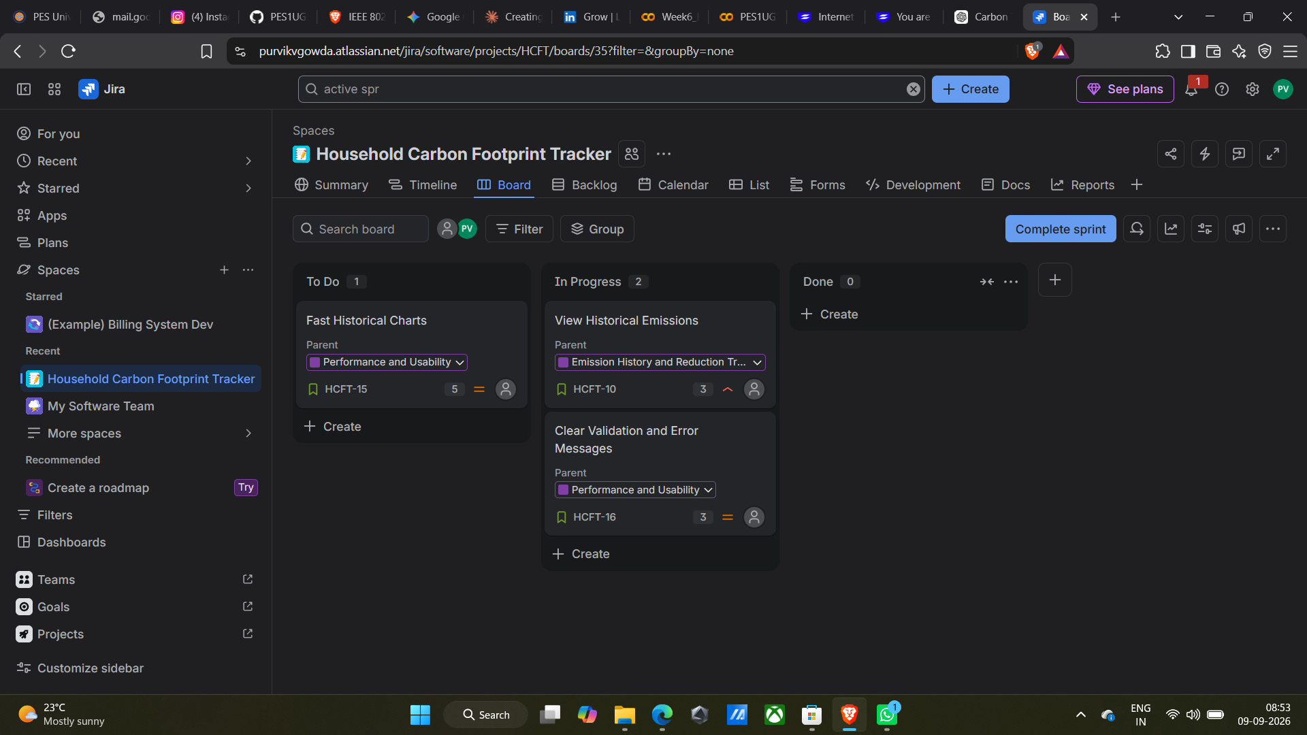
.

STORY POINTS

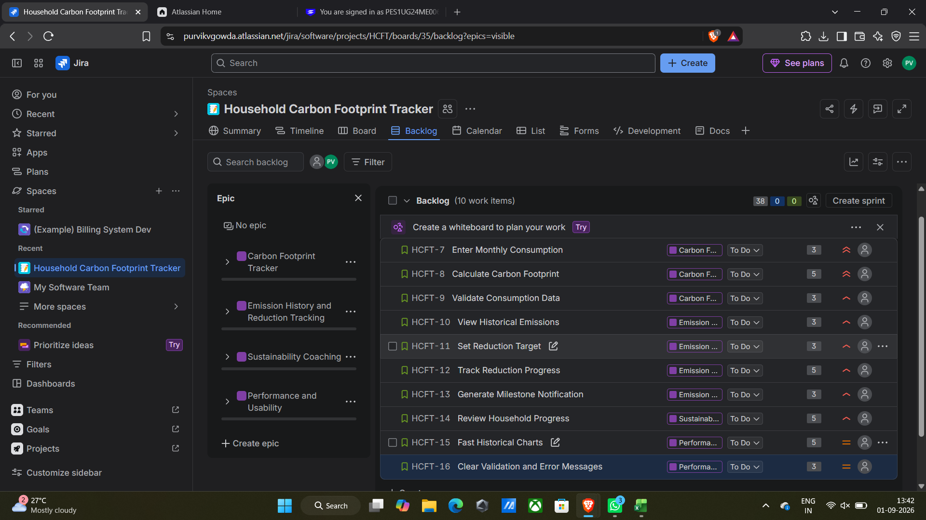

2. Individual Lab Reflection
Working on the Household Carbon Footprint Tracker helped me understand how a software project can be divided into smaller and manageable Scrum work items. I learned how features such as viewing historical emissions, displaying historical charts, and providing clear validation messages can be represented as individual stories in Jira. Assigning story points also helped me understand that different tasks can have different levels of effort and complexity. The current sprint uses 3, 5, and 3 story points for the three selected stories, which gives a total of 11 story points.
I also learned how the Jira backlog and sprint board are connected. Moving work into a sprint and tracking it through To Do and In Progress makes the progress of the project easier to understand. The project requirements were also useful in connecting the Jira work with actual system functionality, especially carbon-footprint calculation, emission history, reduction tracking, and input validation.
Overall, this lab improved my understanding of Scrum planning, story-point estimation, sprint tracking, and how requirements are converted into actionable development work. It also showed me the importance of maintaining proper project evidence in Jira, such as active-sprint screenshots and story-point assignments.

3. Project Scope Covered
- Enter monthly household consumption data.
- Calculate the household carbon footprint.
- View historical monthly emissions.
- Set and track carbon-reduction targets.
- Review household progress through the Sustainability Coach role.
- Provide clear validation and understandable error messages.

Submission checklist
- ✓ Active sprint evidence included.
- ✓ Story-point assignment included.
- ✓ Individual lab reflection included.

